Graphs

* The complicated data structure will be easier to work with thanks to our high-level non-code models

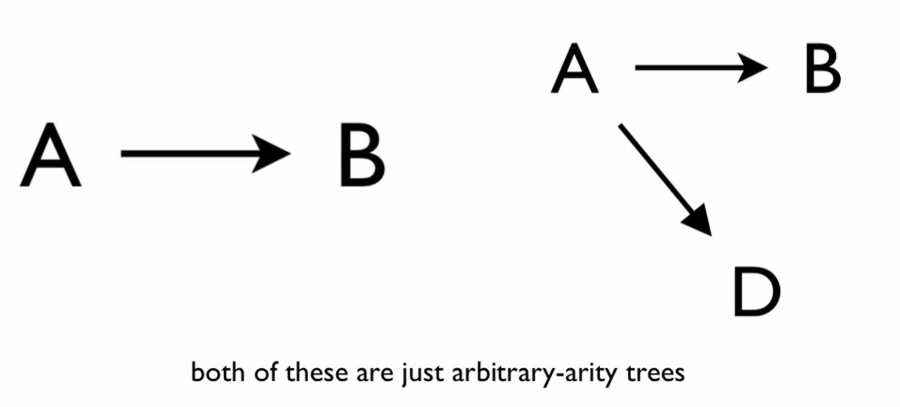

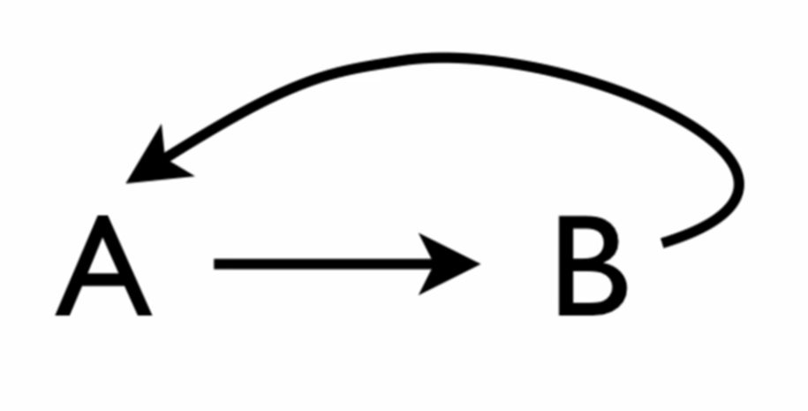

* There is a cycle in this arrangement
* What we call this arrangement is a Graph

2 ways it differs from arbitrary-arity trees

1. Include cycles

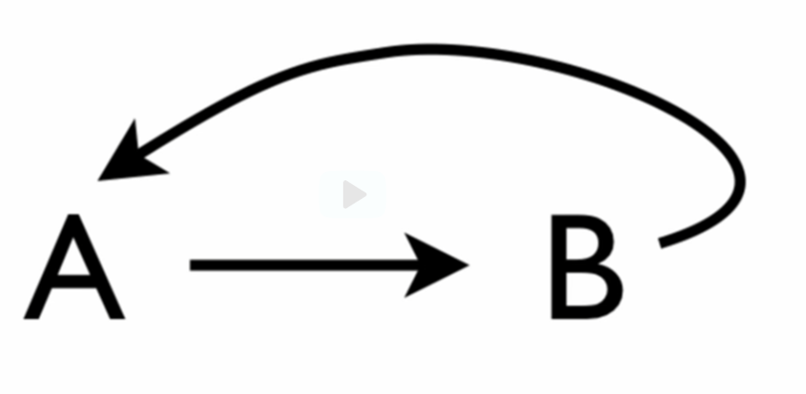

Can also have arbitrary-long cycles

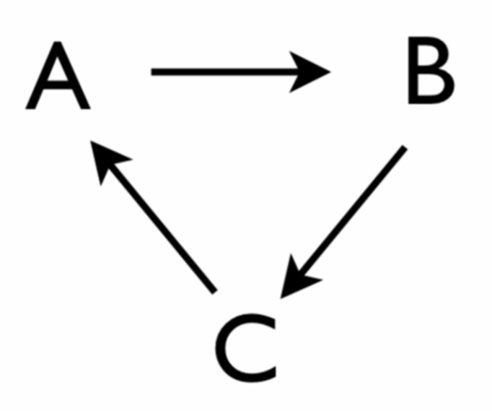

More complicated cycle:

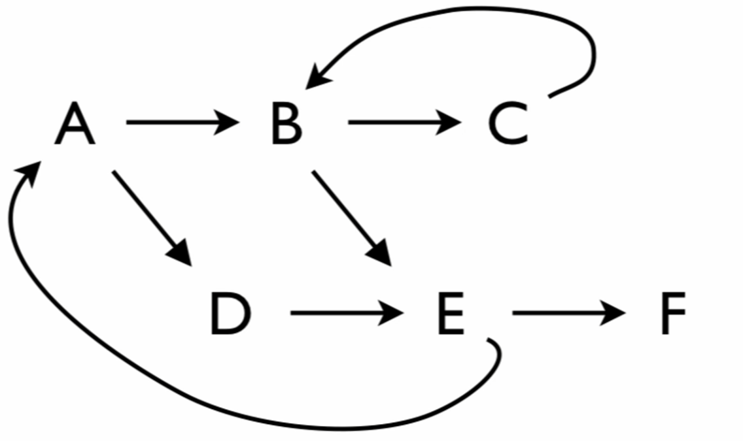

Cycle from BCB

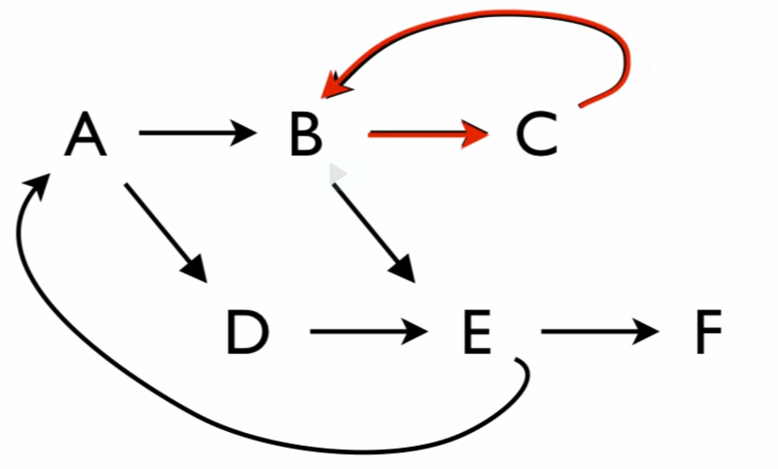

Cycle from ADEA

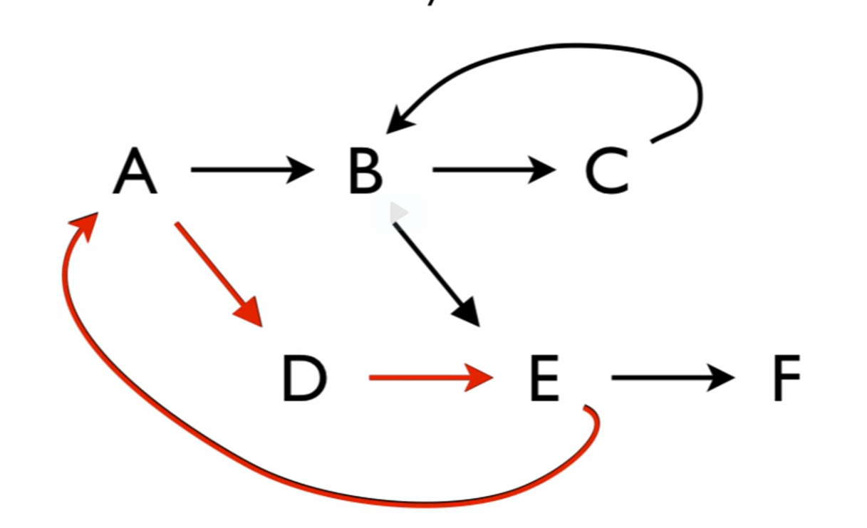

1. Can have multiple arrows going to a single node
   * There can be ZERO or MORE arrows leading to a given node

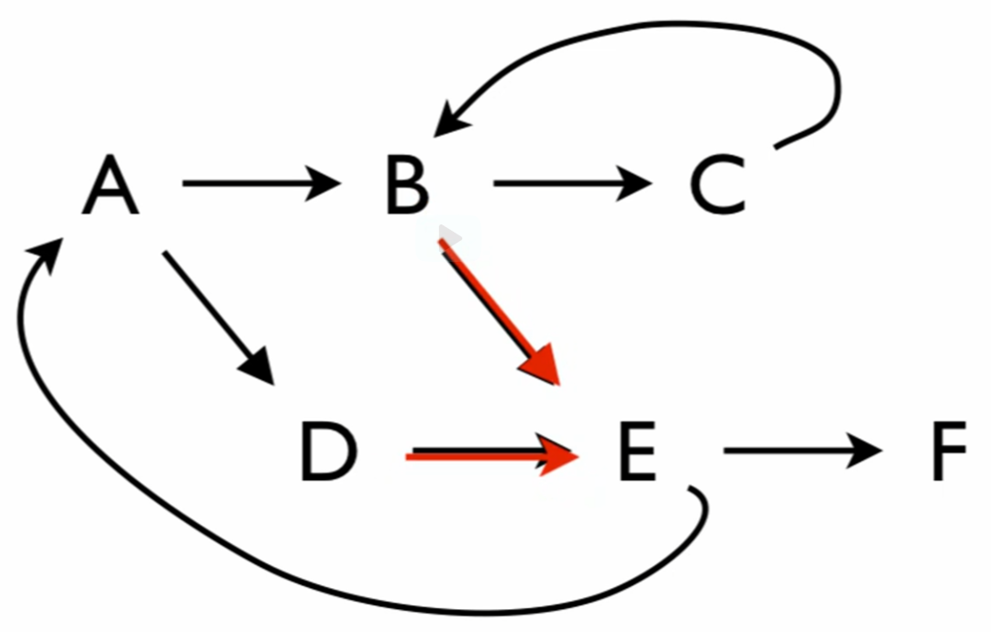

Acyclic graph

* + A graph without cycles
  + Would have more than one arrow leading into some node without cycles

Directed graph

* + Arrows go in only one direction

Cyclic graph

* + Cycles can exist